AI-Native Software Engineering – Emerging Tech Briefing
Transforming software development through autonomous and agentic AI workflows

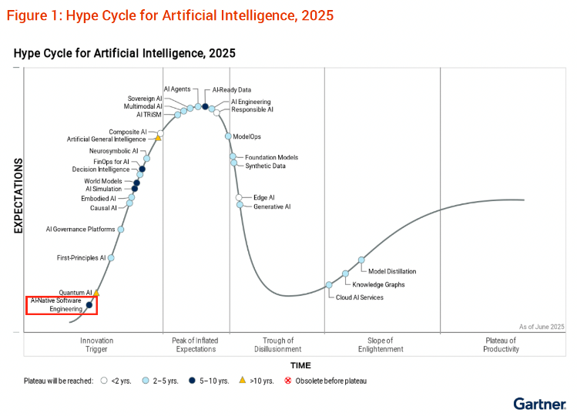
- Introduction: The Rise of AI-Native Software Engineering
Artificial Intelligence (AI) is transforming how software is designed and delivered. While tools such as GitHub Copilot and ChatGPT support human developers, AI-Native Software Engineering (AINSE) goes further by embedding AI at the center of the software development lifecycle (SDLC).
Gartner (2025) defines AINSE as “the autonomous or semi-autonomous execution of software engineering tasks by AI agents integrated throughout the SDLC.” This model positions AI not merely as an assistant but as a co-developer capable of design, coding, testing, and deployment. Developers become orchestrators who direct intelligent agents rather than writing code line-by-line.
According to Gartner’s Hype Cycle for Artificial Intelligence (2025), AINSE is in the Innovation Trigger phase with less than 1 % enterprise adoption but transformational potential. By 2030, 40 % of enterprise applications will be AI-built, and 80 % of engineering teams will operate as AI-augmented “tiny teams.”

- Technology Overview:
AINSE integrates five layers of capability:
- Principles – Responsible AI and governance ensuring transparency and trust.
- Intelligence – Composite AI models and LLMs that interpret natural-language requirements into code.
- Engineering – Prompt-to-code generation and agentic collaboration across design and testing.
- Infrastructure – AI-optimized DevOps (AIOps) enabling continuous deployment.
- Operations – Self-healing, AI-monitored runtime systems.
These layers enable end-to-end automation: AI agents handle requirement analysis, code synthesis, unit testing, and deployment. Multi-agent frameworks coordinate these functions through autonomous communication and feedback loops (Gartner, 2025). Vendors such as GitHub, Replit, and Windsurf are already building AI-native development environments that convert human intent into executable software.

- Business Impact
AINSE fundamentally redefines the economics and culture of software development. Gartner’s Top Strategic Technology Trends for 2026 reports 3–5× productivity gains and up to 50 % faster delivery cycles in early pilots. Key advantages include:
- Speed and Agility: Text-based requirements can become deployable applications within days.
- Efficiency: Automated testing and documentation cut maintenance costs by 20–30 %.
- Innovation: Engineers focus on creative design while AI performs repetitive tasks.
- Resilience: AI-based observability and self-repair improve uptime and reduce outages.
Industry use cases are growing rapidly. In telecommunications, AINSE enables predictive maintenance and network automation. Financial institutions apply AI-generated audit trails to improve compliance. Manufacturers integrate AI-native digital twins for process optimization. Collectively, these examples illustrate that AI-native architectures deliver tangible productivity and reliability benefits (Gartner, 2025).

- Drivers of Adoption
Five factors accelerate AINSE adoption:
- Advanced Generative AI: Modern multimodal LLMs (e.g., GPT-5, Gemini) support autonomous reasoning.
- Agentic Frameworks: Interacting AI agents collaborate like distributed teams to plan and debug.
- AI-First Infrastructure: Cloud vendors embed ModelOps and AI observability.
- Talent Transformation: Developers acquire AI-orchestration and prompt-engineering skills.
- Cultural Acceptance: Over half of developers report higher satisfaction using AI-enabled workflows.
These forces reduce the barrier between idea and implementation, turning software creation into a co-creative process between humans and intelligent systems.

- Challenges and Risks
AINSE’s maturity depends on overcoming technical, ethical, and organizational risks.
Risk Area | Description / Concern | Key Mitigation
AI Hallucination | Inaccurate or insecure code generation | Human review and explainable AI tools
Security Exposure | Expanded attack surface from agentic workflows | AI Trust, Risk and Security Management (AI TRiSM)
Governance Complexity | Difficulty tracking autonomous agent behavior | Continuous monitoring and audit trails
Bias and Ethics | Embedded model bias and opacity | Responsible-AI policies and transparency
Talent Gap | Limited AI-fluency among developers | Upskilling and continuous learning
Gartner (2025) warns that by 2027, 25 % of software defects in production will stem from inadequate oversight of AI-generated code. Governance frameworks must evolve alongside innovation to preserve accountability.

- Strategic Outlook
AINSE’s development will occur in three stages (Gartner, 2025):
- Experimental (2025–2026): Organizations pilot AI-native tools for narrow use cases.
- Orchestrated (2027–2028): Integrated agentic workflows manage design-to-deployment with maturing governance.
- Autonomous (2029–2030 +): AI systems self-optimize code, security, and performance.
Successful adoption requires a three-pillar strategy:
- People: Build cross-functional AI fluency and align culture toward experimentation.
- Process: Integrate ethical governance and AI risk management into DevOps.
- Platform: Deploy AI-native infrastructure supporting observability, explainability, and compliance.
Early adopters will gain competitive advantage through innovation velocity and cost efficiency, much like the pioneers of DevOps and cloud computing a decade earlier.

- Conclusion
AI-Native Software Engineering is a defining shift in digital transformation. By embedding intelligence into every software lifecycle stage, AINSE enables organizations to create adaptive, self-optimizing systems. Yet, its success relies on balancing automation with oversight.
Enterprises that act early training teams, refining governance, and modernizing platforms will transform AI from a coding assistant into a strategic co-creator of business value. In doing so, they will set the standard for how technology organizations build, manage, and evolve software in the AI-driven decade ahead.

